Students Entering Grade 2
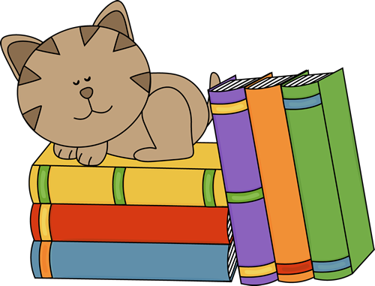
Summer Reading Suggestions
2015

Students entering Grade 2 enjoy reading a variety of topics and types of books. Mysteries, poetry, realistic fiction, fables, and nonfiction are popular with rising second graders. They love to share read-aloud books such as picture books and illustrated nonfiction books, and read-alone books such as Step/Level easy readers, series books, and chapter books.

Chapter books are particular favorites since these books are long enough to be split into chapters, but not long enough or deep enough to be called a novel. Many chapter books have illustrations, but not as many as a true picture book. Chapter books are considered “transitional” books, because they fall between beginning Step/Level readers and novels, and often appeal to reluctant readers of all ages.

Successful reading begins as a relaxing and enjoyable experiences so during the summer months, children should follow their reading interests and choose their own reading materials. Visit James Patterson’s Read Kiddo Read website for summer reading suggestions as well as year-round recommendations. Great ideas for transitional and page-turner books! http://readkiddoread.com/

THE FIVE FINGER RULE 

There are so many great books from which to choose. How do you know if a book is right for you? Try the “Five Finger Rule” to help you choose just the right book.

Open the book to a full page of text, and begin to read.
Hold up a finger for every word you come to that you cannot pronounce or do not know.
0 - 1 finger...easy 2 – 3 fingers...just right 4 - 5 fingers...hard

If you get 5 fingers up on one page, the book is too difficult to read independently, but it may be fine to read with someone. If you do not get any fingers up, but are reading very slowly and sounding out almost every word, you may not enjoy the book. This book might be better if someone reads it to you first, then you can try it on your own.

By using the Five Finger Rule, you are practicing to read smoothly and with expression, while improving your sight vocabulary.

The Caldecott Medal is awarded each year by the American Library Association (ALA) to honor the illustrator who had created the most distinguished children’s picture book published during the preceding year. The award was named in honor of nineteenth-century English illustrator Randolph Caldecott.

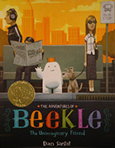
2015 Medal Winner

This magical story begins on an island far away where an imaginary friend is born. He patiently waits his turn to be chosen by a real child, but when he is overlooked time and again, he sets off on an incredible journey to the bustling city, where he finally meets his perfect match and-at long last-is given his special name: Beekle.

2015 Honor Books
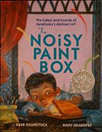
Vasya Kandinsky was a proper little boy: he studied math and history, he practiced the piano, he sat up straight and was perfectly polite. And when his family sent him to art classes, they expected him to paint pretty houses and flowers--like a proper artist.
But as Vasya opened his paint box and began mixing the reds, the yellows, the blues, he heard a strange sound--the swirling colors trilled like an orchestra tuning up for a symphony! And as he grew older, he continued to hear brilliant colors singing and see vibrant sounds dancing. But was Vasya brave enough to put aside his proper still lifes and portraits and paint . . .music?
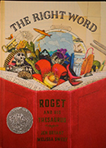
For shy young Peter Mark Roget, books were the best companions -- and it wasn't long before Peter began writing his own book. But he didn't write stories; he wrote lists. Peter took his love for words and turned it to organizing ideas and finding exactly the right word to express just what he thought. His lists grew and grew, eventually turning into one of the most important reference books of all time.
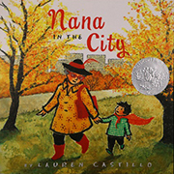
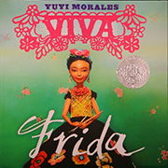
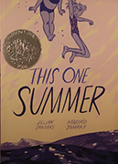
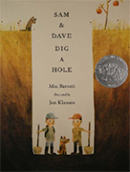

A young boy is frightened by how busy and noisy the city is when he goes there to visit his Nana.
She makes him a fancy red cape that keeps him from being scared as she shows him how wonderful a place the city can be.
Text in English and Spanish.

Introduces the reader to Mexican artist Frida Kahlo.
Sam and Dave are on a mission to find something spectacular. So they dig a hole. And they keep digging. And they find . . . nothing. Yet the day turns out to be pretty spectacular after all.
Attentive readers will be rewarded with a rare treasure in this witty story of looking for the extraordinary -- and finding it in a manner you'd never expect.
Rose and her parents go on vacation to Awago Beach like they do every year, but this year Rose's mom and dad won't stop fighting and she turns to her friend Windy for help dealing with her troubled family life.

Pictures from - http://www.ala.org/alsc/awardsgrants/bookmedia/caldecottmedal/caldecottmedal
Descriptions from - titlewave.com
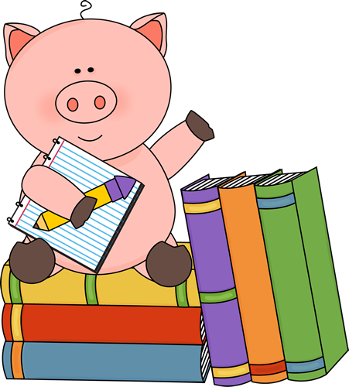

The following book lists have been compiled from 2 sources: the American Library Association’s 2015 Notable Book List and Children’s Choice Book Awards at Children's Choice Awards 2015 .

Each year, the ALA recognizes “notable” books, books that are especially outstanding in their field, and encourage children’s interests. These exemplary books can be picture books, works of fiction, information books, or poetry for children birth through age 14. For a complete list of ALA’s Notable Books and go to: http://www.ala.org/alsc/awardsgrants/notalists/ncb

The Adventures of Beekle: The Unimaginary Friend. By Dan Santat. Illus. by author.
In four delightful chapters, Beekle, an imaginary friend, undergoes an emotional journey looking for his human. Vibrant illustrations add to the fun. (2015 Caldecott Medal Book)

Blizzard. By John Rocco. Illus. by the author.
Blizzard is based on author’s childhood experience during the now infamous Blizzard of 1978, which brought fifty-three inches of snow to his town in Rhode Island. Told with a brief text and dynamic illustrations, the book opens with a boy's excitement upon seeing the first snowflake fall outside his classroom window. It ends with the neighborhood's immense relief upon seeing the first snowplow break through on their street. This book about the wonder of a winter storm is as delicious as a mug of hot cocoa by the fire on a snowy day

The Chicken Squad: The First Misadventure. By Doreen Cronin. Illus. by Kevin Cornell.
Tail, a scaredy-squirrel, seeks refuge and help from the Chicken Squad, four problem-solving chicks. This illustrated chapter book brings each chicken's zany personality to life.

Dory Fantasmagory. By Abby Hanlon. Illus. by the author.
Move over, Junie B. Jones and Ivy & Bean! Here comes a lovably energetic little sister with a BIG personality—and an imagination to match! In this charming take on family life, irrepressible Dory drives her siblings crazy with her wild imagination until she finally gets them to join in on the fun.

Kali's Story: An Orphaned Polar Bear Rescue. By Jennifer Keats Curtis. Ilus. by John Gomes.
Follow the rescue of orphaned polar bear cub, Kali, from the Inupiat village of Point Lay to the Alaska Zoo in Anchorage to his new home at the Buffalo Zoo in New York. This photographic journey beautifully captures the remarkable development of the cub, who initially drinks from a baby bottle, sucks his paw for comfort, and sleeps with a “blankie” as he rapidly grows into the largest land carnivore on earth

Little Melba and Her Big Trombone. By Katheryn Russell-Brown. Illus. by Frank Morrison.
This is beautifully illustrated biography of African American musician, Melba Doretta Liston, a self-taught prodigy and world-class trombone player, composer, and arranger who played the trombone and composed and arranged music for many of the great jazz musicians of the twentieth century.

Mr. Putter & Tabby Turn the Page. By Cynthia Rylant. Illus. by Arthur Howard.
Mr. Putter and his cat Tabby are excited to participate in a library read-aloud program, but they are nervous when Mrs. Teaberry and her unpredictable dog Zeke want to join. (2015 Geisel Honor Book)

Nana in the City. By Lauren Castillo. Illus. by the author.
In this magical picture book, a young boy spends an overnight visit with his nana and is frightened to find that the city where she lives is filled with noise and crowds and scary things. But then Nana makes him a special cape to help him be brave, and soon the everyday sights, sounds, and smells of the city are not scary--but wonderful. (2015 Caldecott Honor Book)

Once Upon an Alphabet. By Oliver Jeffers. Illus. by the author.
A creative, fresh take on the alphabet book! Jeffers tells a short story for each letter, giving each one its due glory. Full of humor and whimsy. Complete with distinctive illustrations that are one of a kind.

The Pigeon Needs a Bath! By Mo Willems. Illus. by the author.
Pigeon returns--this time he needs a bath but has other things to do. When he is finally convinced, he won't get out of the tub. It's a pleasure to join pigeon in another of his wild adventures.

Queen Victoria's Bathing Machine. By Gloria Whelan. Illus. by Nancy Carpenter.
A playful rhyming text brings us to Victorian times and a queen who cannot be seen by her subjects when swimming. Inspired by a true story, Queen Victoria is unable to go swimming without her subjects glimpsing her in a swimming suit, as a result, her husband, Prince Albert, comes up with an innovative solution so his wife can indulge in the healthy exercise.

Zombie in Love. By Kelly DiPucchio. Ilus. by Scott Campbell.
Mortimer is looking for love. And he’s looking everywhere! He’s worked out at the gym (if only his arm wouldn’t keep falling off). He’s tried ballroom dancing lessons (but the ladies found him to be a bit stiff). He’s even been on stalemate.com. How’s a guy supposed to find a ghoul? When it seems all hope has died, could the girl of Mortimer’s dreams be just one horrifying shriek away?

Favorite kid-friendly stories appeal to beginning readers by stretching children’s imaginations and building their vocabularies. They usually are set in “modern” times and do not cover specific years.
“Tired-and-true” books contain excellent writing, memorable characters and outstanding artwork. They are timeless – they remain popular with children and book professionals, generation after generation.

These books can be used as read-aloud and read-alone books. Read-aloud books encourage children to listen to the flow and pace of reading aloud, and gives them confidence to try reading independently. Read-Alone books give children time to practice their newly learned reading skills.

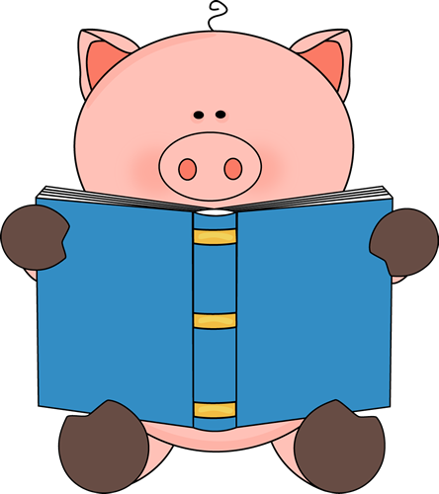

Title Author
Cam Jansen series David Adler
Amelia Bedelia Peggy Parrish
Animal Ark series Ben Baglio
Arthur’s Eyes Marc Brown
Bailey School Kids series Debbie Dadey
The Catcher’s Mask, The Lucky Baseball Bat Matt Christopher
Don’t Let the Pigeon Drive the Bus Mo Willems
Eloise Kay Thompson
Flat Stanley Jeff Brown
Freckle Juice Judy Blume
Herbie Jones series Suzy Kline
Katie Kazoo series Nancy E. Krulik
Magic School Bus series Joanna Cole
Magic Tree House series Mary Pope Osborne
My Father’s Dragon Ruth Stiles Gannett
Officer Buckle and Gloria Gloria Rathmann
The Polar Express Chris Van Alsburg
Seven Blind Mice Ed Young
Stinky Cheese Man Jon Scieszka
Strega Nona Tomie de Paola
Sylvester & the Magic Pebble William Steig


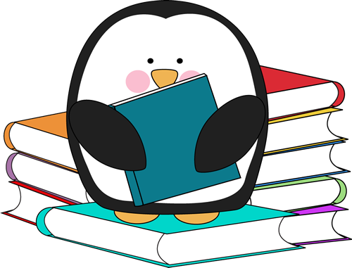

PBS Parents Guide to Reading and Language
Learn how children become readers and writers and how parents can help them develop by talking, reading, and writing together every day.
http://www.pbs.org/parents/readinglanguage/

100 Best Books for Children and Young Adults
http://www.nextreads.com/Display2.aspx?SID=48cf6632-7199-41ce-b0f4-2e775652e88e&N=63249

Harper Collins Bookfinder
Browse for new books, Kids Picks, Honors & Awards, and Favorite Characters & Series from the publisher, Harper Collins for Kids
http://www.harpercollinschildrens.com/Kids/BookFinder/

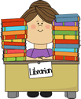

Compiled by Mrs. A. Petrilli
Millington School Library Media Specialist
June 2015

Clipart from http://www.mycutegraphics.com/graphics/classroom-job-images.html

